STEM | English | Humanities | Sports | Music and Arts | PSHE/RE/Spirituality/Eco
Science Club | Year of Reading Author webinar workshop Natasha Farrant  Forest Green Rovers Football and Reading workshops  Cheltenham Literature Festival – Pamela Butchart | Dr Liam Saddington: What is a country?  French Club | Sports Club  KS2 Cross Country  Leadership Workshop  Football Fun Fixtures  Bee Netball  Quicksticks  Tenpin Panathlon  Sports Hall Athletics  Dodgeball  Boccia/Kurling | Brass Band workshops  Choir Club  Art Club | DeVere Hotel Lake Litter Pick  Experience Harvest
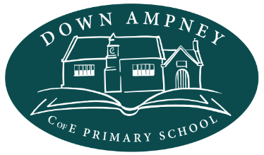

Down Ampney Primary School Enrichment Calendar 2023-2024

