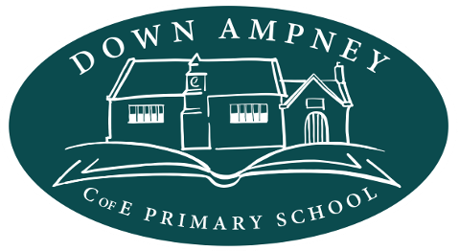

Strategic priorities 2023 to 2028
In the autumn of 2022, the Down Ampney C of E Primary School is thriving and leadership is strong and dynamic. The children enjoy a rich curriculum where everyone strives to achieve their best and resources are used creatively to support the children’s learning underpinned by our Christian vision and values. We hope that everyone will continue to enjoy and strengthen these achievements over the next few years.
In 2022, the governors discussed new strategic priorities for the direction of the school between 2023 and 2028. The priorities set out here respond to consultation with all governors and representatives of staff and parents.

Vision - Everyone Achieving, Everyone Believing, Everyone Caring
Our vision is to create a school community based on Christian teachings within a nurturing environment. We will empower our children to flourish through the development of relationships in order that they have life in all its fullness while developing the confidence and skills they will need to have an impact in our changing world.
The decades ahead promise to be challenging (e.g. climate change, speed of change, the continuing digital revolution). Our role as a school is to set children on a hopeful path where they can understand, question, manage and influence what happens in the future. We want our children to work for the benefit of society, to have a voice and to know how to be heard.

Ethos
Every activity involving the whole school community is strengthened by being caring and thoughtful.
- We care for each other, for ourselves and for local and global communities.
- We are mindful, thoughtful and reflective in everything we do.
- We strive to achieve our best.
- We celebrate success while treating ourselves and others with respect
- We take responsibility for our learning, behaviour and our school
- We are committed to ensuring equality of education and opportunity for all pupils, staff, parents and carers receiving services from the school, irrespective of race, gender, disability, faith or religion or socio-economic background.
- We aim to develop a culture of inclusion and diversity in which all those connected to the school feel proud of their identity and able to participate fully in school life.

Strategic priorities
To achieve our vision of encouraging children to engage actively in local and global communities now and in the future, our priorities are to:
- develop skills that empower our children and support participation, creativity, innovation and problem-solving
- nurture positive relationships supported by effective communication and collaboration and reaching out to others
- foster sensitivity that values and protects the local and global environment for future generations

The paragraphs below explain these three priorities further while recognising that they overlap with each other and with our vision of actively engaging in local and global communities.
Skills: We prepare our children for participating actively in society, helping them to develop the skills, confidence and understanding they need to influence the world around them. We encourage creativity (arts, crafts, music, drama), innovation (design, science, technology) and problem-solving. The aim is to develop skills that are both traditional and modern, equipping our children for living and working in a variety of ways in the 21st century world. This includes learning how to use information and digital technology with care and discretion and as a tool facilitating rather than dominating creativity, collaboration and imaginative thinking.
Positive relationships: We believe that our children need a caring relationship with themselves, understanding what it takes to maintain sound physical and mental health. They also need to be self-aware, confident and sensitive to the needs of others.
Relationships are built on self-expression, good communication skills and learning how to collaborate with others. Learning and teaching is also about the strength of diversity and of inclusive relationships in society, in the classroom and in the playground. Play is as important as lessons for developing positive relationships.
There are real benefits in reaching out to others. Down Ampney C of E Primary school has plenty to give; our small rural school is a leader in its field and we can continue to blaze a trail. We wish to reach out into both our village and those across the Ampney churches’ benefice to strengthen relationships locally.
There is also a need to discover more about the wider world. We can broaden our children’s perspective on our complex society by establishing and maintaining connections with other schools and institutions.
The environment: The natural environment experienced by previous generations is now under threat from climate change and the unsustainable use of natural resources. Accordingly, we want our children to value their environment – not just the wonderful local environment, but the natural world elsewhere in other parts of the globe. They need to understand how the creation of the natural world works, how to convert to a world without fossil fuels and make a difference. For example, we encourage the school to demonstrate this understanding by actively working towards becoming a carbon neutral school.
Our children will need resilience and the agility to handle change. As citizens with social responsibility and resourcefulness, our children can work for a more positive future.

Governors: Down Ampney C of E Primary School November 2022

